# PE16 – Classiest

1. Create a .NET Class Library called CafeLib.dll from the following schUML:

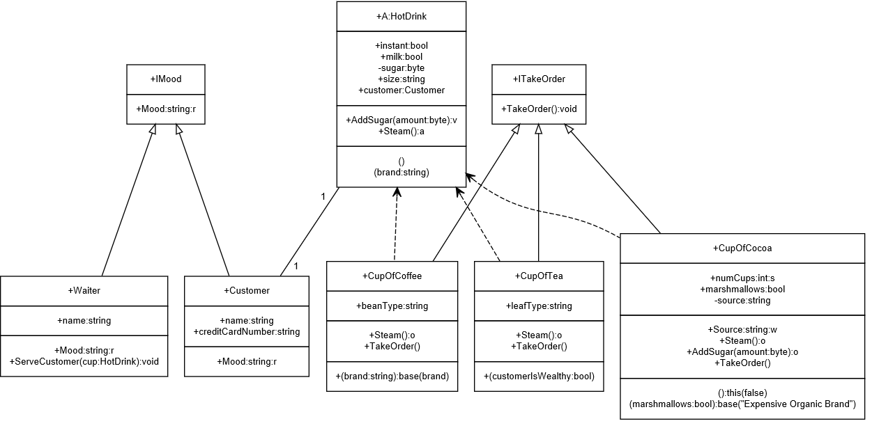

## Submission

Submit the GitHub URL to the corresponding MyCourses dropbox.